Practical no. 8
Name :- Danish Altaf Solkar Enrolment no. :-24111590805
Class :- CO3K – B Subject :- DMS
Aim:- Apply built-in Logical operators on given data

QUERY :- SELECT * FROM emp;
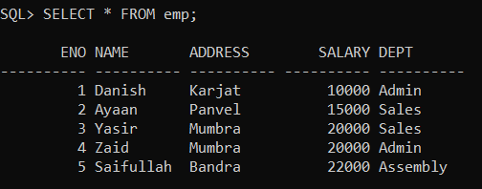

QUERY :- SELECT * FROM emp WHERE NOT salary > 15000;
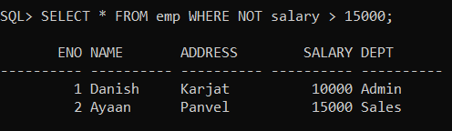

QUERY :- SELECT * FROM emp WHERE salary > 15000 AND dept = 'Admin';
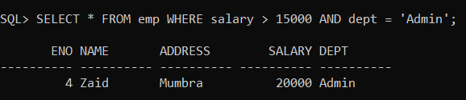
QUERY :- SELECT * FROM emp WHERE salary > 20000 OR dept = 'Admin';
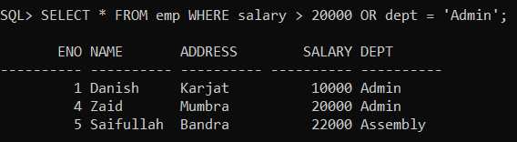
QUERY :- SELECT * FROM emp WHERE salary BETWEEN 20000 AND 30000;
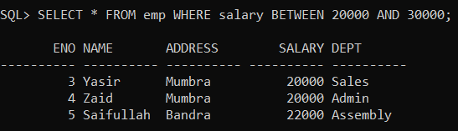
QUERY :- SELECT * FROM emp WHERE salary IN (10000,20000);
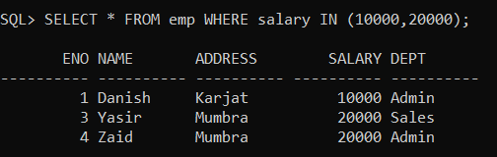

QUERY :- SELECT * FROM emp WHERE address IN ('Mumbra','Karjat');
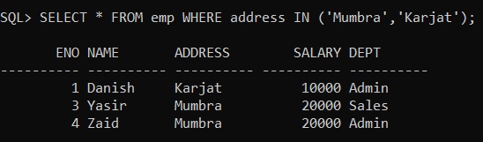

QUERY :- SELECT * FROM emp WHERE name LIKE 'A%';
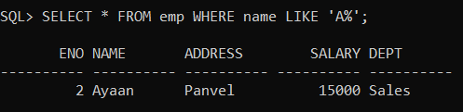

QUERY :- SELECT * FROM emp WHERE address LIKE '%a'; 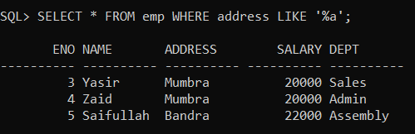

QUERY :- SELECT * FROM emp WHERE name LIKE '%a%';
